1.
#pragma warning(disable:4996)
#include <stdio.h>
int main() {
int a[10], max = 0x80000001, maxi = 10;
for (int i = 0; i < 10; ++i) {
scanf("%d", &a[i]);
}
for (int i = 9; i >= 0; --i) {
printf("%d ", a[i]);
if (max < a[i]) {
max = a[i];
maxi = i;
}
}
printf("\n");
printf("The position of the maximal number is: %d\n", maxi);
return 0;
}
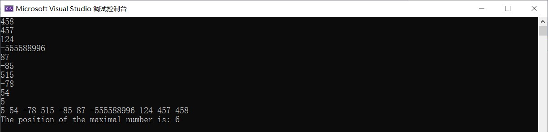
4.
#pragma warning (disable:4996)
#include <stdio.h>
int main() {
int a[4][6], min = 0x7fffffff, minx = -1, miny = -1;
for (int i = 0; i < 4; ++i)
for (int j = 0; j < 6; ++j) {
scanf("%d", &a[i][j]);
if (min > a[i][j]) {
min = a[i][j];
minx = i;
miny = j;
}
}
printf("最小元素行下标是: %d;\n最小元素列下标是: %d;\n", minx, miny);
return 0;
}

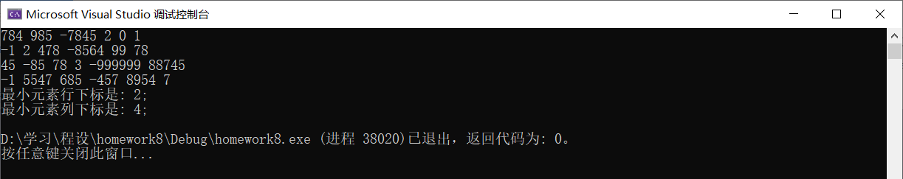
5.
void Func(int a[5][5], int b[5]) {
int min;
for (int i = 0; i < 5; ++i) {
min = 0x7fffffff;
for (int j = 0; j < 5; ++j) {
if (min > a[i][j]) min = a[i][j];
}
b[i] = min;
}
for (int i = 0; i < 5; ++i) {
for (int j = 0; j < 5; ++j)
printf("%10d", a[i][j]);
printf(" ||%10d\n\n\n", b[i]);
}
return;
}
10.
#pragma warning (disable:4996)
#include <stdio.h>
int Isdigit(char ch) {
if (ch <= '9'&& ch >= '0') return 1;
return 0;
}
int Isalpha(char ch) {
if (ch <= 'z' && ch >= 'a' || ch <= 'Z' && ch >= 'A') return 1;
return 0;
}
int main() {
int numOfDig = 0, numOfAlpha = 0;
char c;
for (int i = 0; i < 50; ++i) {
scanf("%c", &c);
if (Isdigit(c)) ++numOfDig;
else if (Isalpha(c)) ++numOfAlpha;
}
printf("The number of letter(s) is %d;\nThe number of digit(s) is %d; \n", numOfAlpha, numOfDig);
return 0;
}

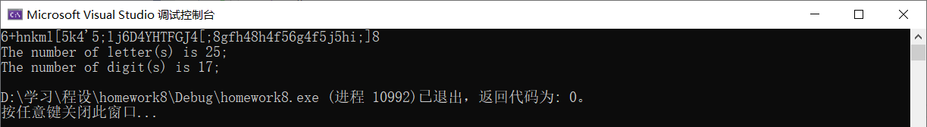
12.
#pragma warning(disable:4996)
#include<stdio.h>
int main() {
int year, month, day, leap = 0, days = 0;
int a[13] = { 0 , 31 , 28 , 31 , 30 , 31 , 30 , 31 , 31 , 30 , 31 , 30 , 31 };
printf("PLease input the year, month and day.\n");
scanf("%d%d%d", &year, &month, &day);
if (year >= 2001) leap = ((year - 2001) / 4 - (year - 2001) / 100 + (year - 2001) / 400) + 1;
else if (month > 2) leap++;
days += ((year - 2000) * 365 + leap);
if (year % 4 == 0 && year % 100 || year % 400 == 0) a[2]++;
for (int i = 0; i < month; ++i) days += a[i];
days += day;
int k = (days - 1) % 5;
if (k < 3) printf("打鱼\n");
else printf("晒网\n");
return 0;
}
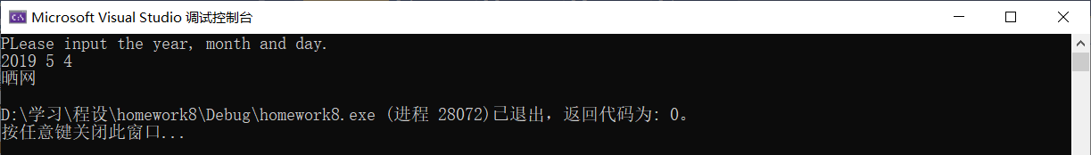

超长整数乘法：
#pragma warning (disable:4996)
#include<stdio.h>
char a[10000], b[10000], c[20000] = {0};
int main() {
char tmpch;
int ai = 0, bi = 1, ci = 0;
for (int i = 0; i < 10000; ++i) {
tmpch = getchar();
if (tmpch <= '9' && tmpch >= '0') {
a[i] = tmpch - '0';
++ai;
}
else break;
}
while ((tmpch = getchar()) > '9' || tmpch < '0');
b[0] = tmpch - '0';
for (int i = 1; i < 10000; ++i) {
tmpch = getchar();
if (tmpch <= '9' && tmpch >= '0') {
b[i] = tmpch - '0';
++bi;
}
else break;
}
int bi0 = bi;
while (bi > 0) {
ci = bi0 - bi;
--bi;
for (int i = ai - 1; i >= 0; --i) {
c[ci] += b[bi] * a[i];
if (c[ci] > 9) {
c[ci + 1] += c[ci] / 10;
c[ci] -= c[ci] / 10 * 10;
}
++ci;
}
}
if (c[ci] == 0) --ci;
for (; ci >= 0; --ci) printf("%d", (int)c[ci]);
return 0;
}
